(Black) Teen Literacy Matters This project is Open Sourced , [**View project on Github**](https://github.com/High-School-Remixed/teen-literacy-matters)

# An Industry Certificate Toward High School Graduation (proposed)

|  |  |  |
| --- | --- | --- |
| For one graduation point on Ohio’s graduation standards. |  | [Ohio’s Industry-Recognized Credentials Program](http://education.ohio.gov/Topics/Ohio-s-Graduation-Requirements/Industry-Recognized-Credentials)🔗 |

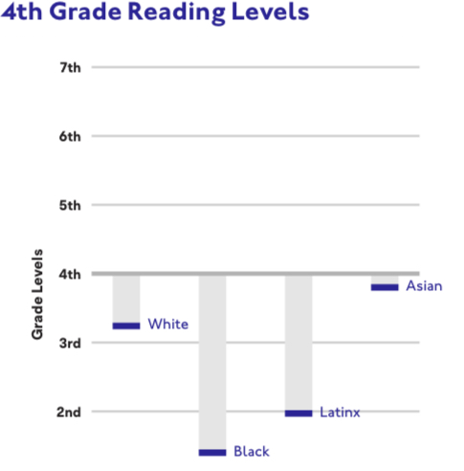

# Introduction: Short video introducing the certificate and the topic.

# I Why Is Reading Still a Problem for Black and Brown Teens? Why Should Other Teens Care?

|  |  |
| --- | --- |
| Lesson | Time |
| [A Hard Truth](http://growinggoodschools.blogspot.com/2018/01/a-hard-truth.html) Learners will write 3-4 good sentences about what this article makes them think or feel, or what questions it provokes. | .5 hr |
| [Reading Vs Prison](https://youtu.be/F1Pvoz1zxDA) This is probably not the best video. What would be better? Learners can submit anything--video, TikTok, they feel captures the spirit of this lesson for teens who will come after. | .5 hr |
| [How ‘Reading Instruction’ Fails Black And Brown Children](https://www.forbes.com/sites/nataliewexler/2020/06/06/how-reading-instruction-fails-black-and-brown-children/#6cc06b144ebe) Learners will read this Forbes article, answer 3-4 questions, and write a paragraph so that the assessors can gain a sense of the student’s writing level.  Possible questions:   * How would you describe Forbes magazine as a source? * What background and expertise does the author bring to this article? * Move this slider to show the percentage of Black 4th graders who are taught to read proficiently. * Now, move this slider to show the percentage of White 4th graders who are taught to read proficiently. * What two things does Ms. Wexler say *do* work to teach early grade learners to read? * What things that teachers do does she say do *not* work? | 1 hr |

# 

# II All Kids Can Read

Intro video: [Every Kid Can Learn to Read](https://docs.google.com/document/d/1mx2E3n4XGuxC2o9KWIBAcSSFTknrlz6zfJR5vBL-f5k/edit)

# II a There is No Age Too Old for Phonemic Awareness Training

Phonemes are the distinct units of sound used to pronounce words. All through our lives, we’ll need them to learn new words.

Many people reach adulthood without knowing them. In English, [there are 44](https://www.dyslexia-reading-well.com/44-phonemes-in-english.html).

|  |  |
| --- | --- |
| Lesson | Time |
| [A Conversation with Jasmine Lane](http://www.buzzsprout.com/612361/2597875-a-conversation-with-jasmine-lane)  In this podcast, high school teacher Jasmine Lane talks about her many teens who never properly learned to read.  Focus on these three segments:  At 7:48, Ms. Lane describes what it’s like for these teens when they encounter new words.  Starting around 11:33, she describes what she’s looking for when new kids first enter her classroom. She tells how she helps make sure all kids get the most out of her English class. Could this also work in history, social studies and other classes?  At 13:58, she talks about decoding lapses.  How do you feel when she describes how her teens are excited to learn that decoding is a thing, and there really are patterns and methods for breaking apart words? | .4 hr |
| [Reading Multi-Syllable Words](https://youtu.be/5xXEWm-6bnE)  Here’s a great example of what Ms. Lane was talking about. Fortunately, Xavier isn’t a teen. He’s in third grade! Xavier is getting the personal training he needs, right when he needs it.    Because Ms. Farrell is a specialist, we know that Xavier was somewhat behind others in his class. That’s OK, he’ll catch up now. His school has a well designed *intervention* program.  But many kids go through third, fourth, fifth, and--as Ms. Jasmine just explained!--through sixth, ninth, and even 12th grades, never learning what Xavier is learning here.  We just love watching Xavier’s face through this video. What does it seem like he’s feeling or wondering through much of the lesson? And, then, after about 8:00, things start to change. What does his expression say then? | .4 |
| [How to Learn the Letters and Sounds of the Alphabet](https://youtu.be/LlTw0oiLNys) This video shows some of the most basic things every young child should master in school. Yet many teens find they have never been properly taught these.  Are any surprising to you? | .2 |
|  |  |

# 

# II b The Sciences of Reading

Many different sciences have come together over the past forty years to tell us how kids learn to read.

|  |  |
| --- | --- |
| Lesson | Time |
| [Introductory video](https://docs.google.com/document/d/1REiXBLv-EAA2kf6hRRaZnHlUX241B40KGCl6eO4C0xE/edit?usp=sharing) | .1 |
| [The Van Orden Experiment](https://youtu.be/bjqsI-JH4Os)  [Can we get some teens or college students to remix this?]  [Create an assessment. Via | .3 |
| [We’re Just Not Wired to Read](https://youtu.be/wlYZBi_07vk)  Why not? What kind of sciences show us this here? | .3 |

# III Stumbling Blocks Millions of young children have specific troubles with different basic skills of reading.

# All schools should catch these issues. Every school should help every child leap past them. Unfortunately, most schools don’t.

|  |  |
| --- | --- |
| Lesson | Time |
| [Blending Sounds in Syllables with Autumn, Kindergartener](https://youtu.be/HFw9cEEXjLE)  Here, little Autumn is hung up on a skill that many children just get automatically. If she receives help at a young age, it will save her so many problems. |  |
| [Letter Names with Reese, Kindergartener](https://youtu.be/VKN3oJVBvEw) Reese struggles with his letters. This can be normal in preschool and kindergarten. But the longer kids aren’t given specific help, the more they miss out as the reading lessons roll on. |  |
| [Looking at Reading Interventions](https://www.readingrockets.org/shows/reading-interventions) |  |

# 

# 

# IV Comprehension

In tens of thousands of classrooms, teachers have students work on ‘comprehension skills’. Do you remember? Did yours?

We now know better.

|  |  |
| --- | --- |
| Lesson | Time |
| [The Baseball Study](https://youtu.be/qP6qpSrr3cg)  [Can we remix this?] |  |
|  |  |

# 

# V Dig Deeper / Pursue More

Complete the 10 hour requirement by choosing among these lessons options.

Learners can choose any combination.

|  |  |
| --- | --- |
| Lesson | Time |
| [Reading Rockets](https://www.readingrockets.org/teaching/reading101-course/welcome-reading-101)  Learners create an assessment on some elements of this site. |  |
|  |  |
| [Science of Reading the App](https://apps.apple.com/us/app/science-of-reading/id1480512339)  Learners complete lessons in this app. |  |

# VI Action

|  |  |
| --- | --- |
| Lesson | Time |
| [Teen Trendsetters](https://www.barbarabush.org/teen-trendsetters/): Teens can help 1st-3rd graders level up their reading. |  |
| [Teach Your Child to Read in 100 Easy Lessons](https://www.amazon.com/Teach-Your-Child-Read-Lessons/dp/0671631985) How to help kids struggling to read. On the Amazon page, you should be able to see a preview of this book.  What surprises you, concerns you, inspires you, intrigues you, informs you in this preview? Write 50-100 words telling us. |  |